The Project Management Life Cycle

People usually get confused with the term project management process and delivery process. This article will help you understand the difference between the project management process and the delivery process and explain briefly about the project management process.

Delivery process v/s Project management process

Let us get some clarity about the differences between the delivery process and the project management process and who's doing what.
Firstly let’s consider the delivery process. The delivery process is what your team members are primarily engaged in and are doing. These are definition, design, development, deployment, and departure. So that's the delivery process. Then comes the project management processes in which the project manager will be doing initiation of the project, planning of project, execution, monitoring, and controlling and closing (project management lifecycle as documented from project management body of knowledge produced by PMI the project management institute).

Project Management Process | Delivery Process
- Initiation | - Definition
- Planning | - Design
- Execution, Monitoring, and controlling | - Development
- Closing | - Deployment
 | - Departure

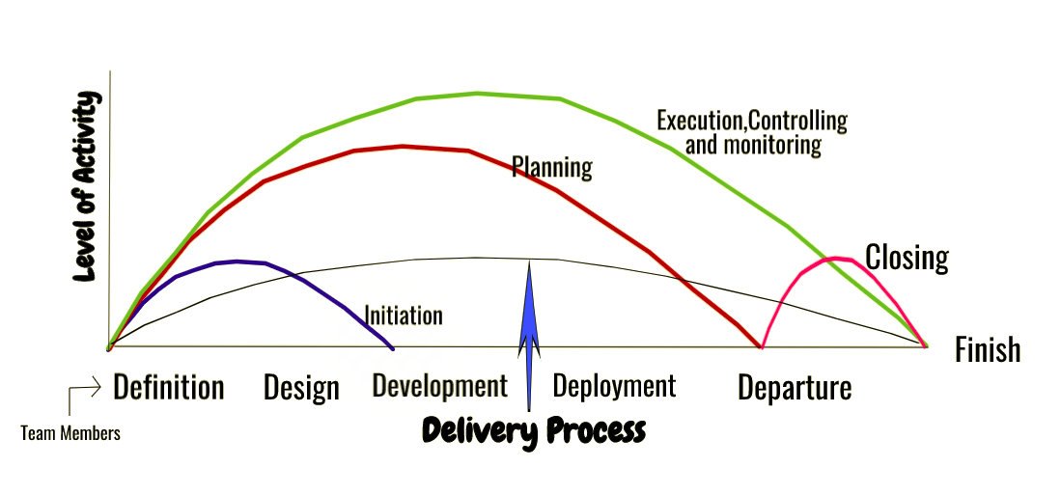
Project Management Process

Looking at this cross-section you can see the delivery phase, the project management phase, and the trends depict the level of activity going on. Therefore, as seen in the above graph for the delivery process, it starts from the project definition and then it begins to build, and then it tapers off towards the finish. But for project management, is taking a different approach than the delivery process.

Initiation

Let’s start with the first process group in project management; and that’s initiation.
We will use the construction of this boat as an example explaining the process groups simple.
For the initiation process group, you have two important processes; the First process is that you develop a project charter. And the second process is you identify stakeholders. Let’s start with Project Charter. The project charter is a fairly simple document outlining a few things. It’s like a mini project plan. Essentially, we are finding an answer to; why you are doing what you are doing.

So, in my case, if I have to develop a project charter for building this boat, it would include my objectives, scope, a rough idea for the cost and time, key stakeholders, and milestones. At the initiation stage, you don’t want the document to be very detailed. We need the details later for the planning stage.
So, in your case, your project charter may be as simple as explaining why you consider the expansion to foreign markets, why you are considering building that new factory. It talks about the business case and maybe high-level project objectives, major deliverables, and roles and responsibilities. The reason we do that is to have a buy-in. Support from the leadership to spend more time and maybe money to properly plan it. At first, your project sponsor may not even want this project at all, If they say no, you don’t start planning. Maybe they don’t want to expand into a new market, maybe they don’t want to have that new factory.

The second process for the initiation process group is Stakeholder Identification. At this stage, You will not categorize all the stakeholders based on their influence. So, all you do is, create an excel list and list down various stakeholders that you will engage with. This is called the Stakeholder Register.

Planning Phase
The next phase, the planning phase. This phase can start along with the Initiation Phase. In this phase where the project is further developed in as many more details as possible and the steps necessary to meet the project’s objective are planned. Here we are coming out with the processes, the schedule, the milestones, and all of the main deliverables to be produced in that project. The planning starts from project definition to departure in the delivery process.
A project plan is created with all activities, tasks, dependencies, and timeframes. The project manager coordinates with the project team for the preparation of a project budget by providing cost estimates for the labor, equipment, and materials costs. The budget is used for monitoring and controlling cost expenditures during project implementation.

Executing, monitoring, and controlling
In this phase of the project management process, the project plan is put into motion and the work of the project is performed. This phase starts with the Definition of the project to the finish of the project in the delivery process.
Progress is monitored continuously and appropriate corrections are made and recorded as variances from the original plan. The project manager spends most of the time in this step. The project manager produces the performance reports for the project. He will be gauging where are we now and where should we be. The project manager uses this variance information to maintain control over the direction of the project by comparing the progress reports with the project plan and then corrective action as taken. The project manager will be also managing the issue log, risk log, changelog and also monitoring the deliverables.

Closing Phase
The last phase of the project management process is where the emphasis is on releasing the final deliverables to the customer, handing over project documentation to the business, terminating supplier contracts, releasing project resources (demobilization of resources), and then communicating the closure of the project to all stakeholders. The final remaining step is to conduct lessons-learned studies to examine what went well and what didn’t.

